# eService 6.8.2 Release Notes

## Major Changes

### Company Information section change

We had experienced a lot of challenges with client company and invoicing company validation in eservice due to recent year industry business practices change. This major change has addressed most of issues around this.

1. Add explicit flag "IS Client" in company information section, there must be one and only one company can be flagged as a client.

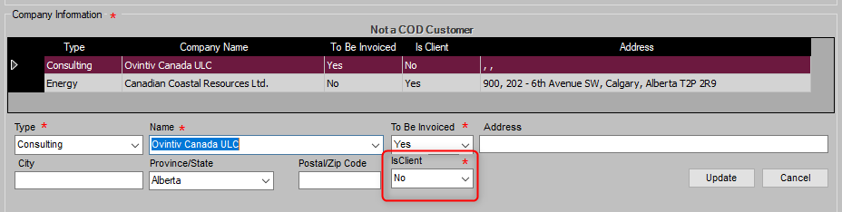

1. Existing "Is To Be Invoiced" flag indicates who is going to pay Sanjel. There must be one and only one company can be flagged as an invoicing company.
2. Company Type will be label only, there is no validation against company types. We can add more than two companies in call sheet to include all stakeholders. However, Job Design Template will stay with existing business rules of company type until corresponding change will be made.
3. Add a validation in Call Sheet to ask dispatch reselect the company in the dropdown list if there is no company id imported in program.

* 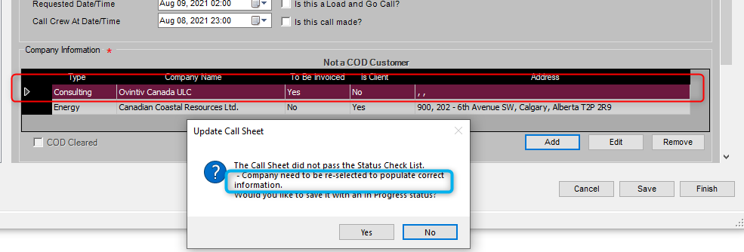

1. COD customer will be checked again who is flagged with "To Be Invoiced".
2. Call Sheet, Field Service Ticket and Approved Service Ticket are updated to apply above changes. Clearly labels if the second company is a consulting company only or it is also be invoiced. The address will be always the invoicing company address.

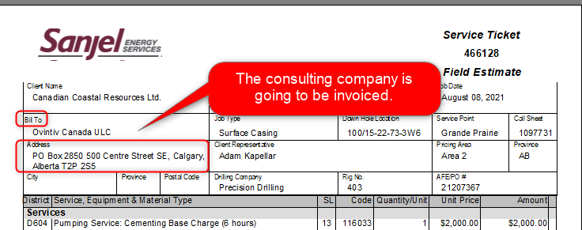

### Eliminate Call Sheet Export/Import

As the network coverage getting significant improved, we are able to create job package online instead exporting to an USB file. This will save supervisor's time and avoid a couple of failure points.

1. Remove the "Export" button under "Call Sheet From Server" tab.
2. Remove the "Call Sheets From Local" tab.

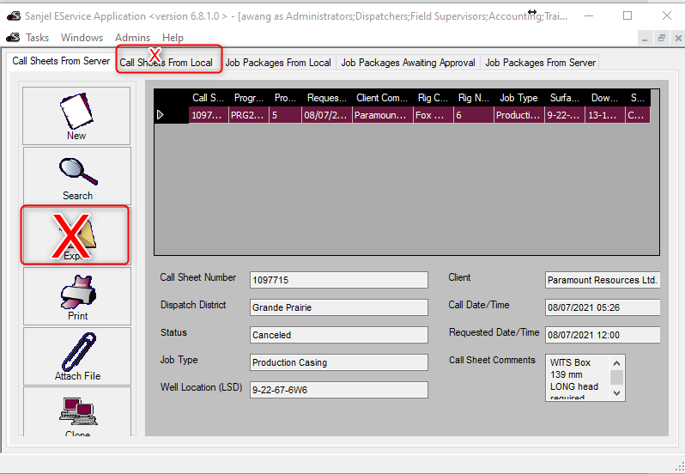

1. Select dispatched Call Sheet (Ready status) while creating job package on local

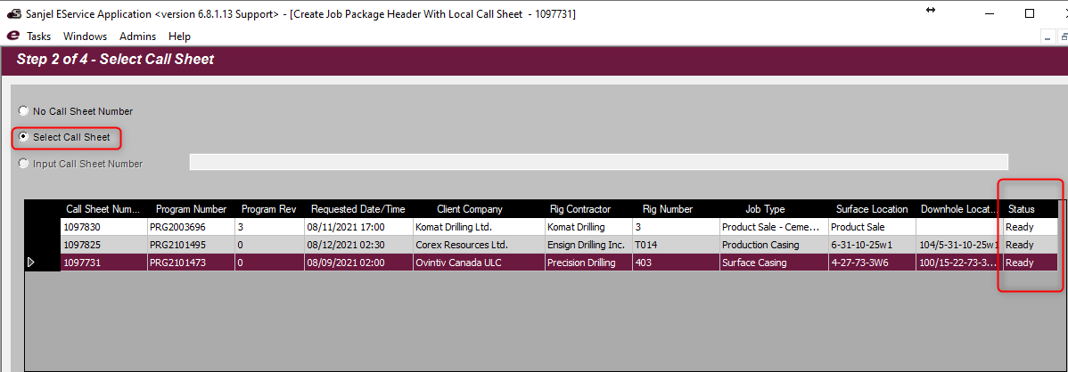

1. All other functions are maintained same.

#### What to do if the call sheet is locked

Sometimes dispatch may need to create a job again from a call sheet. However, call sheet will be locked once it is used to create a job. Under following circumstances, you can handle it or work around it.

* Job is postponed and needs to be reschedule. Use "Postpone" function.
* Incomplete Job. Use "Input Call Sheet Number" function to work around. However, the RigBoard status will go wrongly, please notify IT.
* Issues in creating job. Use "Input Call Sheet Number" function to work around.

### Push Back job for Re-approval

Allow authorized personnel to push back an approved job package to "Awaiting Approval" status.

Under "Job Packages From Server" tab, click on an approved job, the "Revert Approval" button will be enabled. Click on the button, the selected job will be sent back for re-approval.

Following Integrations are not triggered by the revert.

* AX - Needs to push invoice again if billing information is changed
* SCORE - The changes in Performance won't be updated automatically. Manual update in score is needed.

The personnel who reverts the job needs to send email following department regarding the change.

* IT
* Accounting
* HSE

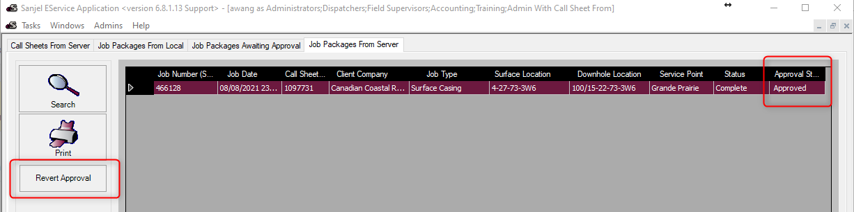

### No Service Report needed for Product Sale Job

Any validation in the job package header is still required, but no service report will be added to the job.

### Depth label wording change

There are always different understanding of the direction of Depth From and Depth To. We reword these two terms to Depth Top and Depth Bottom in all UI and printout.

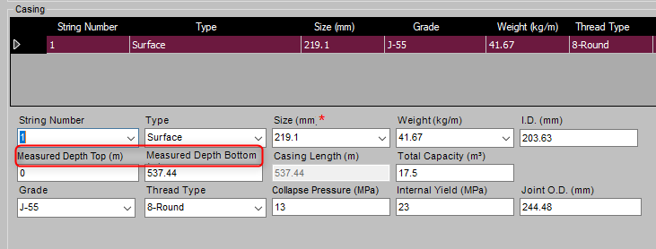

## Bug Fixes

* Search call sheets/jobs earlier than 2009 not working
* Pricing items missing in Service Ticket printout and total miscalculated.
* Rig is not activated automatically when a call sheet is created using it.